May monthly report
โครงการ P2451496 งบยุทธ_CCU68_การต่อยอดและพัฒนาเทคโนโลยี Carbon capture and utilization (CCU) ที่มีความต้องการจากภาคอุตสาหกรรม และขับเคลื่อน National CCUS Alliance ร่วมกับเครือข่ายพันธมิตร
Sothearoth Heng
Under the supervision of
Dr. Pongkarn Chakthranont
ใบสั่งจ้างเลขที่ PO25005060
จ้างเหมาพัฒนางานจ้างพัฒนาการขยายขนาดเซลล์ไฟฟ้าเพื่อการผลิตแก๊สสังเคราะห์จาก CO₂ เชิงเคมีไฟฟ้า
งวดที่ 1: 1 พฤษภาคม 2568 – 31 พฤษภาคม 2568
……..........................................................
Dr. Pongkarn Chakthranont

- To-do list for May
- 25cm² electrolyzer - Stability of Ni0.25SAC (m/l = 1.8±0.2mg/cm²) with 0.25M KOH - IrO₂ under 300ml/minCO₂ at 100mAcm²
- 25cm² electrolyzer - Stability of Ni0.25SAC (m/l = 1.8±0.2mg/cm²) with 0.25M KOH - IrO₂ under 30ml/minCO₂ at 100mAcm²
- 25cm² electrolyzer - Stability of Ni0.25SAC (m/l = 1.8±0.2mg/cm²) with 0.25M KOH - IrO₂ under diluted 15%CO₂/85%N₂ condition (200ml/min) at 100mAcm²
- Experimental Procedure
Membrane electrode assembly set-up
A 25 cm² MEA electrolyzer was used to evaluate the CO2RR performance under modulated operating conditions. The Ni foam (5.4 x 5.4 cm), bipolar membrane (BPM, 6 x 6 cm), and NiSAC (5 x 5 cm) were employed as the anode, membrane, and cathode electrode, respectively. The MEA was assembled and tightened with a torque force of 35 inch-lbs. 200 ml of 1M KOH was recirculated and used throughout the experiment as the anolyte at 25 ml/min. The humidified CO₂ gas stream was introduced into the cathodic inlet with a total CO₂ flow rate of 150 ml/min. Prior the test, the electrochemical impedance spectroscopy (EIS) and Cyclic voltammetry were measured. Meanwhile, the cathodic outlet was directly injected into an online gas-chromatography for gas products analysis.

- Results
Influence of different CO₂ flow rates on CO2RR performance and single-pass CO₂ utilization (SPU)
Understanding the impact of CO₂ supply on CO selectivity and SPU is critically important for experimental design aimed at achieving maximum CO selectivity while maintaining high carbon efficiency. Figure 1 illustrates the influence of CO₂ supply on CO selectivity and SPU. Across all CO₂ flow rates, %FE(CO) and %SPU strongly depend on the CO₂ supply. Higher CO₂ flow rates correlate with increased %FE(CO) and decreased %SPU. At lower CO₂ flow rates (50 and 30 mL/min), a decrease in %FE(CO) was observed due to mass transport limitations. At a CO₂ flow rate of 30 mL/min, the maximum %SPU of 45% was achieved with an %FE(CO) of 73%. However, under a diluted 15% CO₂/85% N₂ mixture with the same CO₂ quantity (30 mL/min) and a total flow rate of 200 mL/min, %FE(CO) further declined to 60%, with %SPU dropping to 37%.
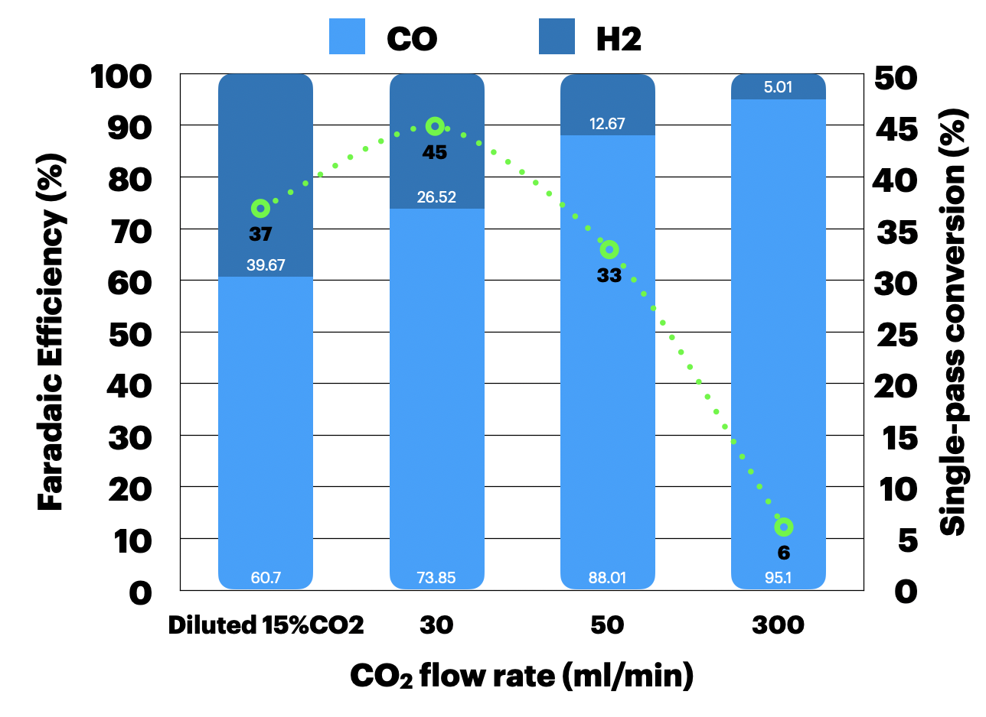
Figure 1. Faradaic efficiency and single-pass conversion of CO₂ electrolysis of Ni0.25SAC (m/l = 1.8±0.2mg/cm²) under different CO₂ flow rates and diluted 15%CO₂ with 25ml/min of 0.25M KOH at 100 mA/cm²

Long-term CO₂ electrolysis of Ni0.25SAC under different CO₂ flow rates
To investigate the tradeoff between high CO₂ conversion and system durability, long-term CO₂ electrolysis of Ni0.25SAC was conducted at various CO₂ flow rates and under diluted 15% CO₂/85% N₂ conditions at a current density of 100 mA/cm². As shown in Figure 2, the system maintained high CO selectivity and stability, achieving an %FE(CO) of 95% and an %SPU of 6% at a CO₂ flow rate of 300 mL/min over 25 hours of operation. Reducing the CO₂ flow rate revealed higher CO₂ conversion but poorer system durability due to mass transport limitations. At a CO₂ flow rate of 50 mL/min, the system sustained an %FE(CO) of approximately 90% with an %SPU of 33% over a shorter operational duration of 12 hours. Further decreasing the CO₂ flow rate to 30 mL/min resulted in an even shorter cell lifetime, with an %FE(CO) of 73% and an %SPU of 45%. Based on these results, we hypothesized that a diluted 15% CO₂/85% N₂ condition (total flow of 200ml/min), with an equivalent CO₂ flow of 30 mL/min, might solve the mass transport issue and improve system durability. However, this condition performed even worse than the pure 30 mL/min CO₂ condition. These findings indicate that an insufficient CO₂ supply at 30 mL/min leads to mass transport limitations and promotes competitive hydrogen evolution reaction (HER) over time.
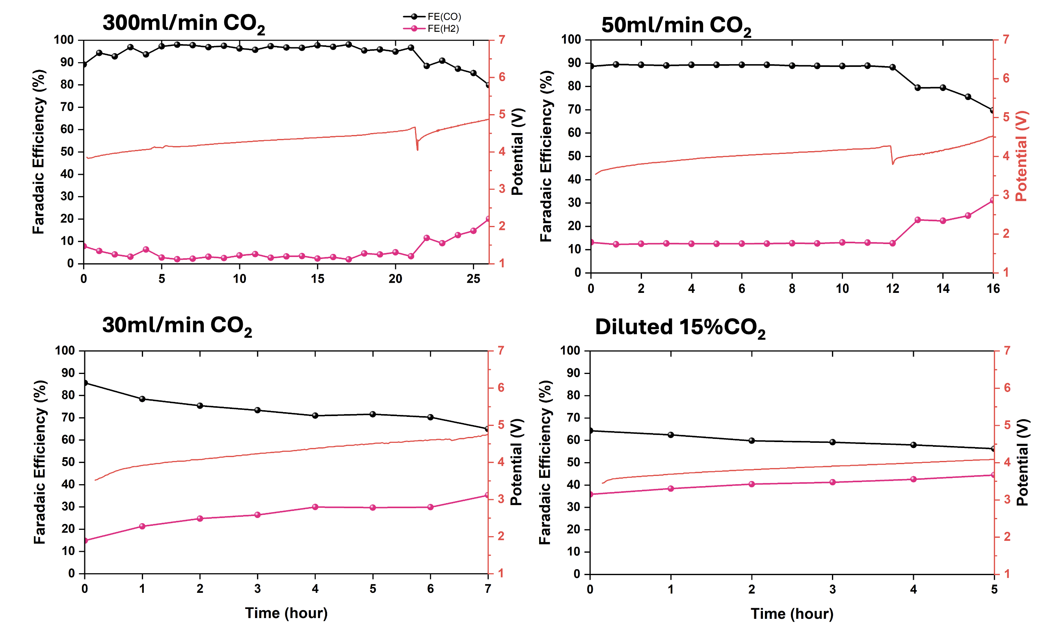
Figure 2. Long-term CO₂ electrolysis under different CO₂ flow rates and diluted 15%CO₂/N₂ (200ml/min) conditions with 0.25M KOH and IrO₂-TiPt anode at 100mA/cm²
- Upcoming tasks
- Investigation of pressurized 25cm² MEA of Ni0.25SAC with 0.25M KOH – IrO₂ under 30ml/minCO2 at 100mA/cm²
- 25cm² electrolyzer – Long-term CO2 electrolysis of Ni0.25SAC with 0.1M KOH – IrO₂ under 30ml/minCO₂ at 100mA/cm²

